Designing for iOS

**iOS embodies the following themes:**

* **Deference.** The UI helps to people to understand and interact with the content, but never competes with it.
* **Clarity.** Text is easy to read at every size, icons are accurate and clearer, adornments are slim and appropriate, and a sharpened focus on functionality motivates the design.
* **Depth.** Visual layers and realistic motion gives vitality and hikes people’s delight and understanding.

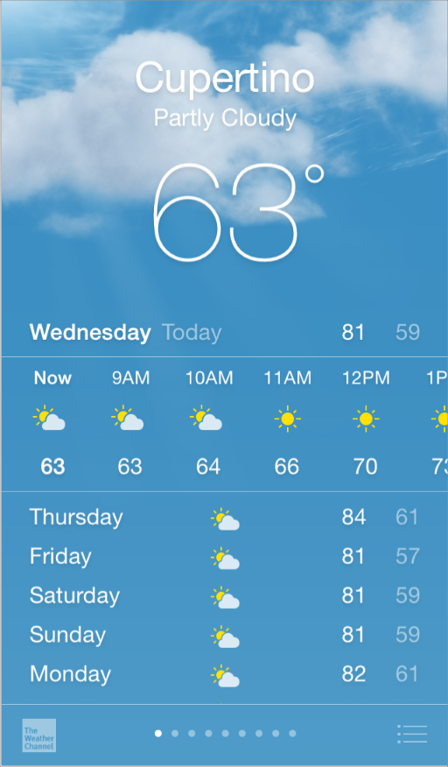

**Whether we’re redesigning an older app or creating a new one, we have to consider approaching the job in this way:**

* We have to look first at past UI to the app’s core functionality and affirm its relevance.
* Next, use the themes of iOS to inform the design of the UI and the user experience. Add details and make beautiful with care and never simply.
* And finally make sure that the design of the UI can adapt to various devices and modes so that users can enjoy the app in as many contexts as possible.
* Throughout the process, be prepared to avoid previous examples, question assumptions, and let a focus on content and functionality motivate every design decision

### Defer to Content

In the below fig1 shows a crisp, beautiful UI and fluid motion are highlights of the iOS experience, the user’s content is at its heart.

Here are some ways to make sure that your designs elevate functionality and defer to the user’s content.

**Taking advantage of the whole screen:**

Weather is a great example of this approach: Here beautiful full-screen drawing of a location’s current weather instantly conveys the most important information, with room to spare for hourly data.

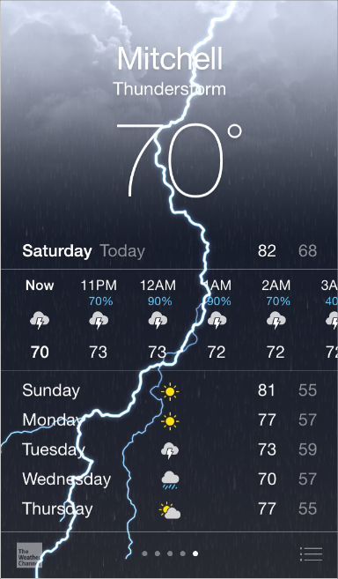

**Reconsider visual indicators of physicality and realism**

 Bezels, gradients, and drop shadows sometimes lead to heavier UI elements that can overpower or compete with the content. Instead, focus on the content and let the UI play a supporting role.

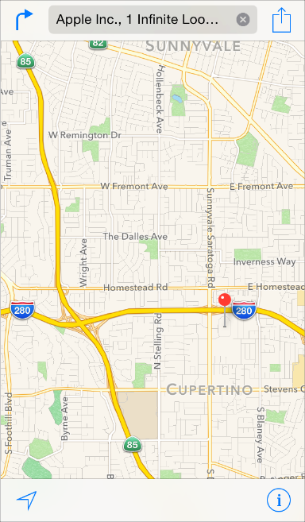

**Let translucent UI elements hint at the content behind them**

  The translucent elements—such as Control Center—provide context, helps to users to see that there are more content is available, and can signal transience. In iOS, a translucent element blurs only the content directly behind it—giving the impression of looking through rice paper—it doesn’t blur the rest of the screen.

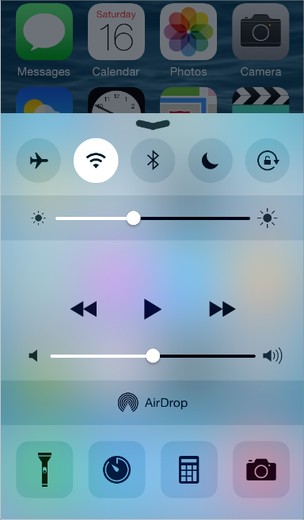

### Provide Clarity

In Apps providing clarity is another way to ensure that content is the major in the app. Here are some ways to make the most important content and functionality clear and easy to interact with.

**Use plenty of negative space**

In Apps the negative space makes important content and functionality more noticeable and easier to understand. Negative space can also gives a sense of calm and cool, and it can make an app look more focused and efficient.

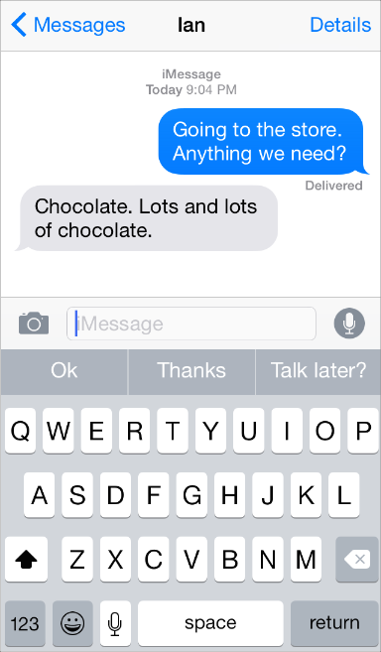

**Let color simplify the UI**

In Apps providing clear fonts to the users to read that content is very important. In below fig shows a key color—such as yellow in Notes—highlights important state information and skillfully indicates interactivity. It also gives an app a consistent visual theme. The built-in apps use a family of pure, clean system colors that look good at every tint and on both dark and light backgrounds.

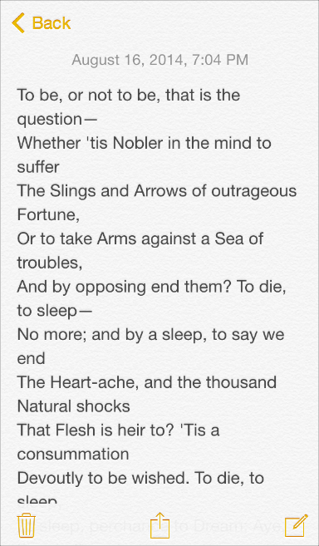

**Ensure legibility by using the system font**

In Apps San Francisco (the iOS system font) works with Dynamic Type to automatically adjust letter spacing and line height so that text is easy to read and looks great at every size. Whether we use San Francisco or our custom font, but we should make sure that to adopt Dynamic Type the app should respond when the user chooses a different text size also.

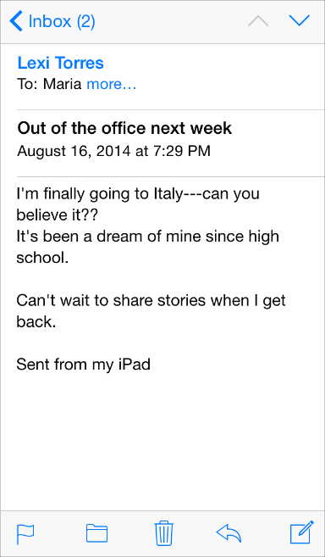

**Embrace borderless buttons**

 By default, all bar buttons are borderless. In content areas, a borderless button uses context, color, and a call-to-action title to indicate interactivity. And when it makes sense, a content-area button can display a thin border or colored background that makes it distinctive.

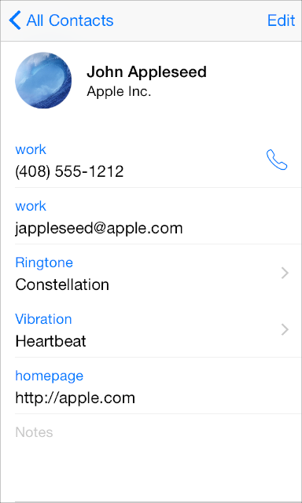

### Use Depth to Communicate

The iOS mobile Apps often displays content in distinct layers that convey hierarchy and position, and that help users understand the relationships among onscreen objects.

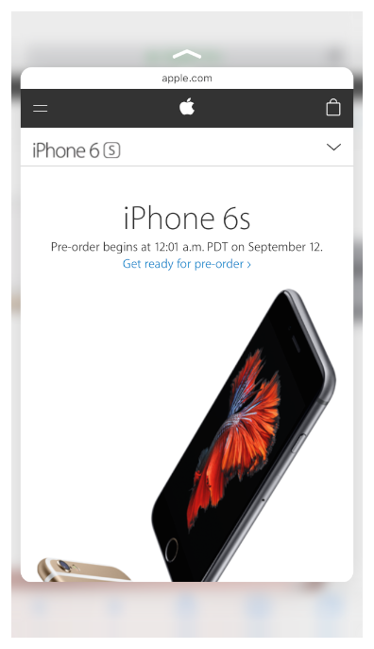

The devices that are support 3D Touch, peek, pop, and quick actions give users access to important functionality without losing their context.

By using a translucent background and appearing to float above the Home screen, folders separate their content from the rest of the screen.

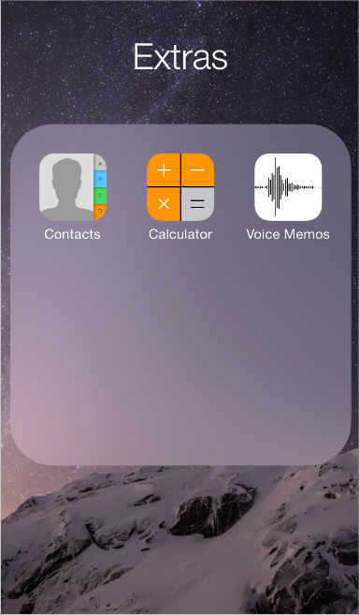

Reminders display lists in layers, as shown below. When users work with one list, the other lists are collected together at the bottom of the screen.

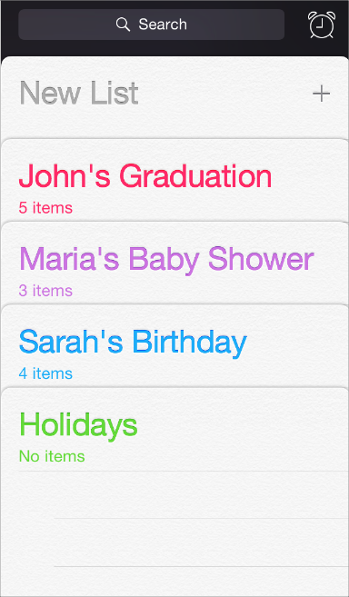

The Calendar uses enhanced transitions to give users a sense of hierarchy and depth as they move between viewing years, months, and days. In the scrolling year view shown below, users can instantly see today’s date and perform other calendar tasks.

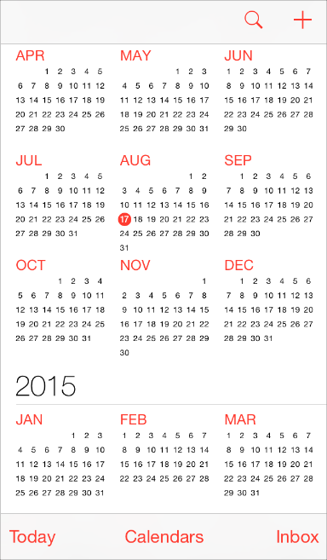

Below fig shows when users select a month, the year view zooms in and reveals the month view. Today’s date remains highlighted and the year appears in the back button, so users know exactly where they are, where they came from, and how to get back.

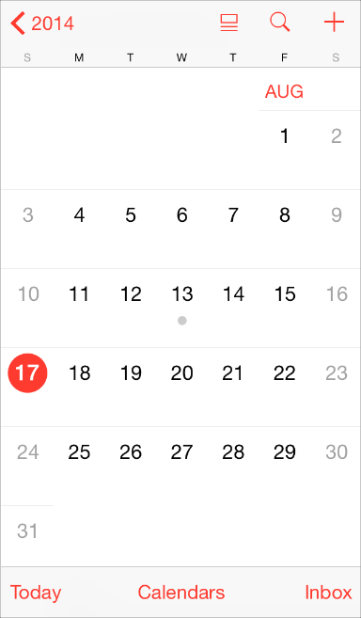

Below fig shows when similar transition happens when users select a day: The month view appears to split apart, pushing the current week to the top of the screen and revealing the hourly view of the selected day. With each transition, Calendar reinforces the hierarchical relationship between years, months, and days.

